Matahom: Beauty and Personal Care Store



In Partial Fulfilment of the Requirements of the Courses:
IT112 – Advanced Database System & IT113 – Event Driven Programming

Balilaon, Sherwin S.
Labanan, Markjun B.
Nantes, Stevine S.
Sedorifa, Rachel Mae
Zerrudo, Jase Karl M.

John Louis Mercaral, MIS
Courses Instructor

December 2025
Table of Contents
I. PROBLEM STATEMENT 1
II. LOGICAL DESIGN 2
Requirements Analysis 2
Entities: 2
Attributes: 2
Relationship & Cardinality: 3
Data Model (ER Diagram): 5
III. PHYSICAL DESIGN 6
SQL Queries: 6
API: 6
IV. Ecommerce: 7
Features: 7
Objectives: 7
Scope and Limitation: 7
Reference 9

- PROBLEM STATEMENT

The beauty and personal care industry is still evolving rapidly because of technological advancements and changing consumer preferences. The growing demand for online accessibility has encouraged many consumers to transition from traditional in-store shopping to e-commerce platforms, where convenience and digital engagement play significant roles in purchasing decisions. The cosmetics sector, in particular, is a dynamic and fast-expanding market that contributes substantially to the global economy [1].
Despite this growth, many local beauty and personal care stores still rely on manual or semi-digital processes for managing their operations. This leads to challenges such as inefficient product tracking, limited online presence, and poor customer engagement. As digital trends and e-commerce innovations continue to reshape consumer expectations, businesses that fail to adopt online platforms risk losing competitiveness in the marketplace [2].
To address these challenges, the project titled “Matahom: Beauty and Personal Care Store” aims to develop a web-based e-commerce system that allows customers to conveniently browse, select, and purchase beauty and personal care products online. The system integrates core functionalities such as product catalog management, shopping cart, order processing, and inventory monitoring. By implementing a centralized and database-driven platform, the project seeks to improve operational efficiency, enhance user satisfaction, and support data-driven business decisions. We also align our system with post-pandemic consumer behavior trends, where online purchasing habits and digital marketing significantly influence customer choices in the skincare and cosmetic industries [3].

LOGICAL DESIGN

Requirements Analysis

Entities:
- Users: Represents the registered individuals using the system, including both customers and administrators.
- Products: Represents the various beauty and personal care items available for sale in the store.
- Category: Represents the different classifications or groupings of products.
- Orders: Represents the records of purchases made by customers within the system.
- Order_Items: Represents the specific products included in each customer order.
- Payments: Represents the payment transactions made by customers for their respective orders.
- Inventory: Represents the tracking and management of available stock for each product.

Attributes:
Users:
- user_id: Unique identifier for each user in the system.
- name: Full name of the user.
- email: Registered email address used for login and communication.
- password: Encrypted password for secure authentication.
- address: Residential or delivery address of the user.
- role: User’s role like admin or customer.
- created_at: The time and date when user account was created.
Products:
- product_id: Unique identifier for each product.
- category_id: Identifier linking the product to its specific category.
- name: Name of the product.
- description: Information about the product’s feature and use.
- price: Selling price of the product.
- stock: Current quantity of the product available for sale.
- image_url: File path to the product’s image.
- created_at: The time and date when user account was created.
Category:
- category_id: Unique identifier for each product.
- name: Name of the category.
- description: Short explanation of what products belong to the category.
- created_at: The time and date when user account was created.
Orders:
- order_id: Unique identifier for each order placed by a customer.
- user_id: Identifier of the user who placed the order.
- total_amount: Total cost of all items in the order.
- status: Current status of the order.
- shipping_address: Delivery address provided by the customer.
- created_at: The time and date when user account was created.
Order_Items:
- order_items_id: Unique identifier for each ordered item.
- order_id: Identifier linking the item to its corresponding order.
- product_id: Identifier linking the item to a specific product.
- Quantity: Number of units of the product purchased in the order.
- Subtotal: Total price for the product based on quantity and unit price.
Inventory:
- inventory_id: Unique identifier for each inventory record.
- product_id: Identifier of the product being tracked in inventory.
- quantity: Number of available units currently in stock.
- updated_at: The date and time when the inventory record was last updated.

Relationship & Cardinality:
- Users – Orders: One-to-Many: A single user can place multiple orders, but each order belongs to one specific user.
- Orders – Order_Items: One-to-Many: Each order can contain multiple ordered items.
- Products – Order_Items: One-to-Many: A product can appear in multiple order items.
- Category – Products: One-to-Many: Each category can include multiple products, but a product belongs to only one category.
- Products – Inventory: One-to-One: Each product has one corresponding inventory record.
- Orders – Payments: One-to-One: Each order corresponds to one payment record.

Data Model (ER Diagram):
Crow’s Foot Notation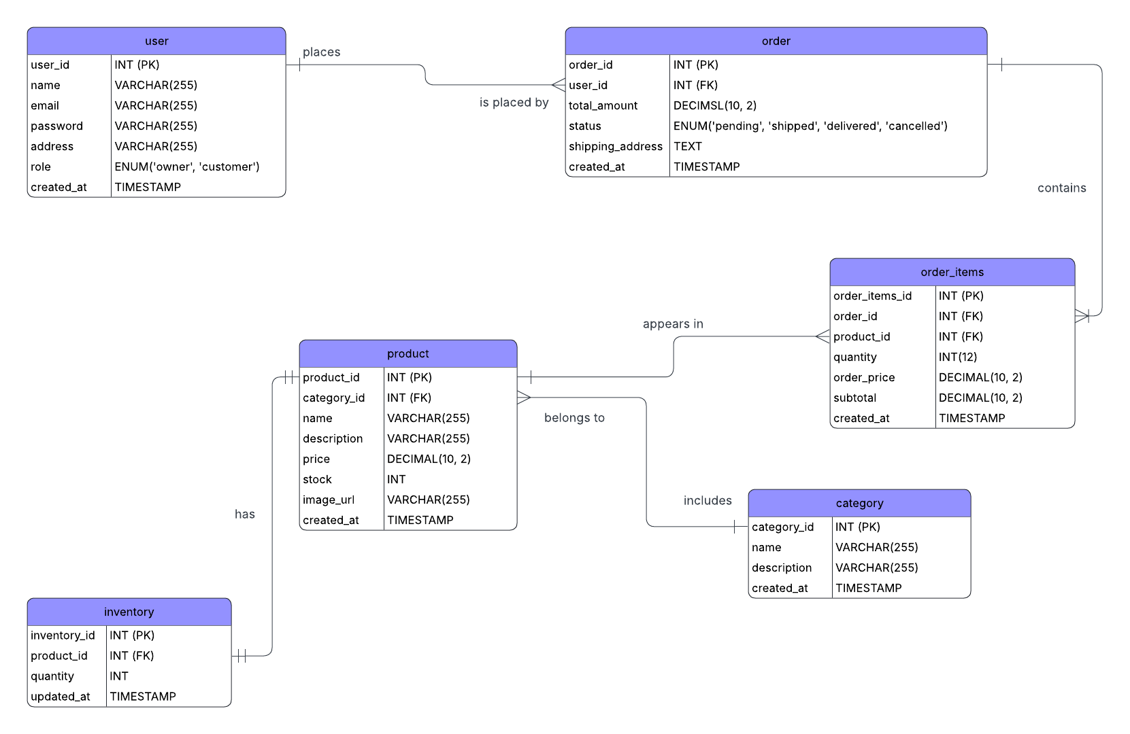
Chen’s Notation
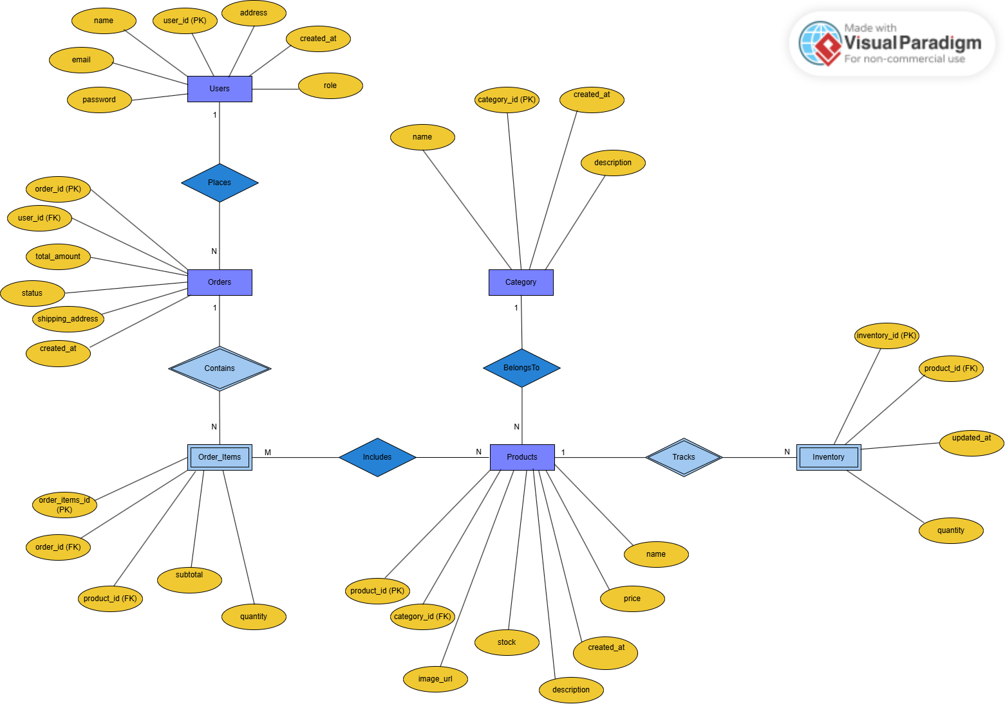

PHYSICAL DESIGN

SQL Queries:
Create tables (DDL)
CREATE TABLE user (
user_id INT AUTO_INCREMENT PRIMARY KEY,
name VARCHAR(255),
email VARCHAR(255) UNIQUE,
password VARCHAR(255),
address VARCHAR(255),
role ENUM('owner', 'customer'),
created_at TIMESTAMP DEFAULT CURRENT_TIMESTAMP
);
CREATE TABLE category (
category_id INT AUTO_INCREMENT PRIMARY KEY,
name VARCHAR(255),
description VARCHAR(255),
created_at TIMESTAMP DEFAULT CURRENT_TIMESTAMP
);
CREATE TABLE product (
product_id INT AUTO_INCREMENT PRIMARY KEY,
category_id INT,
name VARCHAR(255),
description VARCHAR(255),
price DECIMAL(10,2),
stock INT,
image_url VARCHAR(255),
created_at TIMESTAMP DEFAULT CURRENT_TIMESTAMP,
FOREIGN KEY (category_id) REFERENCES category(category_id)
);
CREATE TABLE inventory (
inventory_id INT AUTO_INCREMENT PRIMARY KEY,
product_id INT, quantity INT,
updated_at TIMESTAMP DEFAULT CURRENT_TIMESTAMP ON UPDATE CURRENT_TIMESTAMP,
FOREIGN KEY (product_id) REFERENCES product(product_id)
);
CREATE TABLE order (
order_id INT AUTO_INCREMENT PRIMARY KEY,
user_id INT,
total_amount DECIMAL(10,2),
status ENUM('pending', 'shipped', 'delivered', 'cancelled') DEFAULT 'pending',
shipping_address TEXT,
created_at TIMESTAMP DEFAULT CURRENT_TIMESTAMP,
FOREIGN KEY (user_id) REFERENCES user(user_id)
);
CREATE TABLE order_items (
order_items_id INT AUTO_INCREMENT PRIMARY KEY,
order_id INT, product_id INT,
quantity INT, order_price DECIMAL(10,2),
subtotal DECIMAL(10,2),
created_at TIMESTAMP DEFAULT CURRENT_TIMESTAMP,
FOREIGN KEY (order_id) REFERENCES `order`(order_id),
FOREIGN KEY (product_id) REFERENCES product(product_id)
);

Insert sample data tables
INSERT INTO user (name, email, password, address, role) VALUES
('Alexander Hamilton', 'ham4ham@google.com', 'password123', '1234 Carribean St', 'customer'),
('Aaron Burr', 'a.burr@gmail.com', 'securepass', '555 NYC Ave', 'customer'),
('Hercules Mulligan', 'hercule@gmail.com', 'rizalpogi123', '444 Bikini Bottom St', 'customer'),
('Marquis de Lafayette', 'guns.ships@gmail.com', 'adminpass', '9696 Croissant Blv', 'owner');

INSERT INTO category (name, description) VALUES
('Skincare', 'Products for healthy skin'),
('Haircare', 'Products for shiny and strong hair'),
('Makeup', 'Cosmetics for daily use');

INSERT INTO product (category_id, name, description, price, stock, image_url) VALUES
(1, 'Moisturizing Cream', 'Hydrating face cream', 15.99, 50, 'images/moisture.jpg'),
(2, 'Shampoo Plus', 'Nourishing hair shampoo', 9.99, 100, 'images/shampoo.jpg'),
(3, 'Lip Gloss', 'Shiny lip gloss', 7.99, 200, 'images/lipgloss.jpg'),
(1, 'Facial Cleanser', 'A gentle facial cleanser', 12.99, 150, 'images/facialcleanser.jpg');

INSERT INTO inventory (product_id, quantity) VALUES (1, 50), (2, 100), (3, 200), (4, 250);

INSERT INTO `order` (user_id, total_amount, status, shipping_address) VALUES (1, 25.98, 'pending', '1234 Carribean St'), (2, 9.99, 'delivered', '555 NYC Ave');

INSERT INTO order_items (order_id, product_id, quantity, order_price, subtotal)
VALUES
(1, 1, 1, 15.99, 15.99),
(1, 3, 1, 9.99, 9.99),
(2, 2, 1, 9.99, 9.99);

Update existing data
UPDATE `order` SET status = 'shipped' WHERE order_id = 1;

UPDATE inventory SET quantity = quantity - 1 WHERE product_id = 1;

Delete data
DELETE FROM user WHERE user_id = 3; *Delete product inventory

DELETE FROM inventory WHERE product_id = 4;

DELETE FROM product WHERE product_id = 4;

Select data using various criteria
SELECT * FROM user WHERE role = 'customer';

SELECT * FROM product WHERE price > 10;

SELECT p.name, p.price, c.name AS category FROM product p INNER JOIN category c ON p.category_id = c.category_id WHERE c.name = 'Skincare';

Join tables to retrieve related information
SELECT o.order_id, u.name AS customer_name, u.address, o.total_amount, o.status FROM `order` o JOIN user u ON o.user_id = u.user_id;

SELECT o.order_id, u.name AS customer_name, p.name AS product_name, oi.quantity, oi.subtotal, o.status FROM user u INNER JOIN `order` o ON u.user_id = o.user_id INNER JOIN order_items oi ON o.order_id = oi.order_id INNER JOIN product p ON oi.product_id = p.product_id;

API:

Ecommerce:

Features:
- User Login and Signup: Customers and admins can create accounts and log in to access the system.
- Product Catalog: Users can browse for beauty and personal care products, look for details and search/filter items.
- Item Cart: Customers can add, remove, or update items in their shopping cart.
- Tracking of Inventory/Order: Update automatically the stock of products/items when an order is made.
- Responsive Design: The system works on desktop, tablet, and phone.

Objectives:
To develop a web-based e-commerce system for Matahom: Beauty and Personal Care Store that allows customers to browse and buy beauty and personal care products online.
Specific Objectives:
- To design a product catalog that allows users to search and filter items by category.
- To build an inventory system that updates product stocks automatically after customer purchase.
- To provide an admin dashboard for managing products, order, and customer records.

Scope and Limitation:
The Matahom: Beauty and Personal Care Store is a developed web-based e-commerce platform that automates the process of buying and selling beauty and personal care products. The system allows customers to register and log in, add items to their cart, searching products, and complete their purchases. And, administrators will manage products, orders, categories, and inventory.
Scope:
- The system lets customer register, login, and shop for beauty and personal care items.
- The customers can browse, search/filter, and place order through a simple responsive website.
- The admin can add, edit, and manage the inventory, products, and orders in the system.
Limitations:
- The web-system only focuses on beauty and personal care products.
- The web-system needs internet to work.
- The web-system cannot suggest products automatically.
- Only basic features for shopping and management are included.

Reference
[1] R. N. N. Naseri, M. M. Esa, R. Ibrahim, and Z. Jais, “A Review of Makeup Products, Trends, and Consumer Behaviour,” Journal of Cosmetics and Beauty Research, vol. 8, no. 2, pp. 45–56, 2024.
[2] P. R. Gupta and S. S. Sawant, “A Study of Innovative Trends in E-Commerce with Reference to Beauty and Personal Care Industries,” International Journal of Business and Management Research, vol. 12, no. 3, pp. 110–118, 2023.
[3] M. T. Abtah, “Consumer Behavior Towards Online Shopping Post-Pandemic: A Study on the Skin Care Business Industry,” Zenodo, Feb. 2025, doi: 10.5281/zenodo.14790821.

